ASSIGNMENT SUBMISSION COVER SHEET
Student Id:
Cse25-294

Student names:
Oratile Wada Mbayi

Student email:
Cse25-294@thuto.bac.ac.bw

Cohort:
2026

Assignment title:
SCIS WMD_2026 A01

Date of submission:
22 May 2026

Programme of Study:
Web & Multimedia Development

Year of Study:
Year 1

Intellectual property statement By checking the box below, I certify that this assignment is my own work and is free from plagiarism. I understand that the assignment may be checked for plagiarism by electronic or other means and may be transferred and stored in a database for the purposes of data-matching to help detect plagiarism. The assignment has not previously been submitted for assessment in any other unit or to any other institution.
I have read and understood the Botswana Accountancy College plagiarism guidelines policy.
☐ Agree
22 May 2026
Oratile Wada Mbayi
Signature: Date:

1. Website Specifications
1.1 Website Objectives & Business Goals
Primary Objective:
To establish a professional, accessible, and reassuring digital front door for Riverwalk Medical Centre that streamlines patient access to healthcare services, reduces administrative burden on staff, and builds trust within the community.
Specific Business Goals:
- Reduce Phone Traffic: Divert 30% of routine inquiries (appointments, prescriptions, test results) to the digital platform within the first year.
- Increase New Patient Registrations: Simplify the registration process to attract new families and individuals in the catchment area.
- Enhance Patient Experience: Provide 24/7 access to health resources, booking, and results, improving patient satisfaction scores.
- Promote Preventative Health: Utilize a content hub to share information on immunizations, chronic disease management, and seasonal health alerts.
- Establish Credibility: Convey a sense of modernity, cleanliness, and professionalism to differentiate from competitors.
1.2 Target Audience
Riverwalk Medical Centre serves a broad demographic in Gaborone, Botswana. The target audience is segmented as follows:
Audience Group | Description | Tech Skills | Key Needs
Busy Families | Parents (ages 30-50) managing health for themselves and their children. | Medium to High | Quick appointment booking, after-hours info, list of family-friendly doctors.
Seniors | Retirees (ages 65+) who may have chronic conditions. | Low | Simple layouts, large text, clear buttons, easy-to-find phone number, clear opening hours.
Newcomers | Individuals/families who just moved into the area (ages 25-40). | High | Easy online registration form, location map with parking info, list of services offered.
Tech-Savvy Patients | Working adults (ages 20-50) who prefer digital solutions. | High | Telehealth options, patient portal, online prescription requests.
Corporate Clients | Local businesses and HR managers. | Medium | Clear information on corporate health services, injury management, and billing options.

Primary Audience Summary:
- Existing patients (all ages) who need to book appointments, request test results, or refill prescriptions.
- New patients looking to register with a quality medical practice in Gaborone.
- Parents and caregivers seeking paediatric and family health services.

Secondary Audience Summary:
- Corporate clients and HR managers seeking employee health assessments and flu clinics.
- Healthcare professionals considering career opportunities at the clinic.
1.3 Website Type & Content
Riverwalk Medical Centre's website is a Service/Informational website with Interactive Patient Portal functionality. It falls into the following classifications:
- Informational: Provides detailed content about services, doctors, hours, and clinic background.
- Service-Oriented: Offers functional self-service tools including appointment booking, prescription refills, new patient registration, and test result requests.
- Contact & Lead Generation: Encourages patient contact via the newsletter, forms, phone, and email.
2. Information Design & Taxonomy
2.1 Site Map & Navigation Hierarchy
The website is structured around five primary pages, following the 3-clicks rule so that any patient can reach any piece of information within three clicks from the home page.
Planned Structure:
- Riverwalk Medical Centre (Homepage)
  - Introduction to the Medical Centre website, and its purpose to society.
- About Us page
  - Philosophy / information about the medical centre.
  - Meeting the doctor's profiles and other careers.
- Services page
  - General Practice (GP), Chronic Disease Management, Women's Health, Children's Health, Mental Health & Psychology, Allied Health (Physio, Dietician), Corporate Health (Workplace injuries, checks).
- Patient Hub page (High Priority)
  - Book an Appointment (Calls API/Calendar), Manage My Health (Patient Portal Login), Request a Prescription, Request Test Results, New Patient Registration (Online Form).
- Resources page
  - Health Blog / Articles, Fees & Billing (Medicare, Private Health).
- Contact & Location
  - Opening Hours, After Hours Care Info, Contact Form / Phone.
Implemented Navigation Hierarchy:
Page | Primary Sections | Key Content / Features
index.html (Home) | Hero, Services Preview, Why Choose Us, Testimonials, Newsletter, Footer | Emergency contact card, stats, service highlights, newsletter form
about.html (About) | Our Story, Core Values, Meet the Doctors, Careers CTA | Doctor profiles, founding year stats, mission values
services.html (Services) | Service Cards Grid, CTA, Footer | GP, Chronic, Women's, Children's, Mental, Allied, Corporate Health
patient-hub.html (Patient Hub) | Book Appointment, Test Results, Prescription Refill, New Patient Registration, Resources | Live booking link, 3 forms, health blog, fees info

2.2 Navigation Design
Navigation is consistent across all pages via a sticky Bootstrap navbar. Navigation includes:
- Top Navbar: Home | About Us | Services | Patient Hub + 'Book Appointment' CTA button
- Footer Quick Links: Repeat of primary navigation for accessibility
- In-page anchor links for smooth scrolling (handled in Main.js)
- The 'Book Appointment' button appears both in the navbar and as a dedicated hero CTA, reducing friction to the most important action

3. Page Template Design
The Riverwalk Medical Centre website follows a consistent page template designed for medical professionalism and clarity. The template is built using Bootstrap 5's 12-column grid system and a custom external CSS file (style.css).
3.1 Global Template Structure
Every page follows this layout structure from top to bottom:
- Sticky Navbar --- Logo left, nav links center-right, 'Book Appointment' pill button far right
- Page Header / Hero --- Full-width section with headline, subtitle, and CTA buttons
- Content Sections --- Bootstrap grid rows with white cards, consistent spacing, Font Awesome icons
- Footer --- Dark blue background, 4-column grid with links, hours, social, and contact info
- 3.2 Color Palette & Typography
Element | Purpose
Primary Color | Navbar, headings, buttons, icons
Accent Color | Gradient text, highlights
Secondary | Footer background
Background | Page body background
Body Font | All body copy and UI text
Heading Font | H1, H2, H3 and brand name

3.3 Wireframe Description (Home Page)
The wireframe for the Home page (index.html) follows this layout:
- Row 1: Full-width sticky navbar (logo | links | CTA button)
- Row 2: Hero section --- Left 60%: headline + badge + stats; Right 40%: Emergency info card
- Row 3: 3-column card grid --- Service previews (GP, Telehealth, Chronic Care)
- Row 4: 2-column --- Left: doctor image with floating badge; Right: Why Choose Us feature list
- Row 5: 3-column testimonial cards
- Row 6: Newsletter form left + Emergency number right
- Row 7: Full-width footer --- 4 columns (brand, links, hours, contact)

4. Technical Brief
4.1 What We Will Use to Build the Website
The Building Blocks
The website will be made with standard web languages that all browsers understand. We will use a tool called React that makes the site feel fast and smooth, like an app. For the behind-the-scenes part where staff update content, we will use WordPress. This means anyone at the clinic can add a new doctor, change opening hours, or post a news update without needing to know how to code.

Booking System
We will connect the website to a popular booking platform like HotDoc or HealthEngine. This lets patients see available times and book appointments directly. The system links straight to the clinic's real calendar, so there are no double bookings.
Design Tools
Before building anything, we will use Figma to draw up exactly how the website will look. This lets us agree on the design before any coding begins. We will use Canva or Photoshop to prepare photos, icons, and other images.
Where the Website Lives
The website will be stored on secure servers that keep it running fast and safe. We will add an SSL certificate, which is the padlock icon in the browser address bar. This protects any personal information people enter on forms. We will also set up daily backups, so if anything ever breaks, we can restore the site quickly.
What Matters Most
The website must work perfectly on phones, since most people will visit that way. Pages must load fast --- no one likes waiting. We will make sure buttons are big enough to tap easily, text is large and clear, and the site works for people who use screen readers or have trouble seeing. Finally, clinic staff must be able to update the site themselves without calling a developer.
Putting It Simply
We will use WordPress so staff can easily update content. React will make the site feel fast. A booking tool will connect to the clinic's calendar. The site will be secure, backed up daily, and work great on phones. We will design everything first in Figma to make sure it looks right before building.

Website Flowchart

4.2 Front-End Technologies (Implemented)
Technology | Usage
HTML5 | Semantic page structure, forms, metadata
CSS3 | Custom styling, CSS variables, animations, responsive media queries
JavaScript (ES6) | DOM manipulation, form validation, toast notifications, smooth scroll
Bootstrap | Responsive grid, navbar, utility classes, component scaffolding
Font Awesome | Professional icon set used throughout all pages
Google Fonts | Inter (body) and Playfair Display (headings)

4.3 Development & Authoring Tools
- Visual Studio Code (VS Code) --- Primary code editor for all HTML, CSS, and JavaScript files
- GIMP / Any image editor --- For creating/editing the clinic logo and any custom imagery
- Google Chrome DevTools --- Browser-based debugging, responsive view testing, and performance profiling
- Git & GitHub --- Version control; all project files tracked in a repository named with SCIS student number
- GitHub Pages --- Static site hosting to publish the live website
- W3C Markup Validator --- HTML5 standards compliance validation
- W3C CSS Validator --- CSS3 standards compliance validation

5. Quality Assurance
Quality assurance was carried out across multiple dimensions to ensure the website meets functional, visual, and cross-platform standards as required by the assignment brief.
5.1 Browser Compatibility Testing
Feature Tested | Google Chrome | Mozilla Firefox | Microsoft Edge | Opera
Navbar responsive collapse | PASS | PASS | PASS | PASS
Hero layout & stats | PASS | PASS | PASS | PASS
Service card hover effects | PASS | PASS | PASS | PASS
Forms validation & toast | PASS | PASS | PASS | PASS
Footer grid layout | PASS | PASS | PASS | PASS
Mobile hamburger menu | PASS | PASS | PASS | PASS
Google Fonts loading | PASS | PASS | PASS | PASS
CSS gradient text | PASS | PASS | PASS | PASS

5.2 Mobile & Responsive Testing
The website uses Bootstrap 5's responsive grid and custom media queries in style.css to adapt to various screen sizes. Tests were conducted at the following breakpoints:

Mobile screenshot
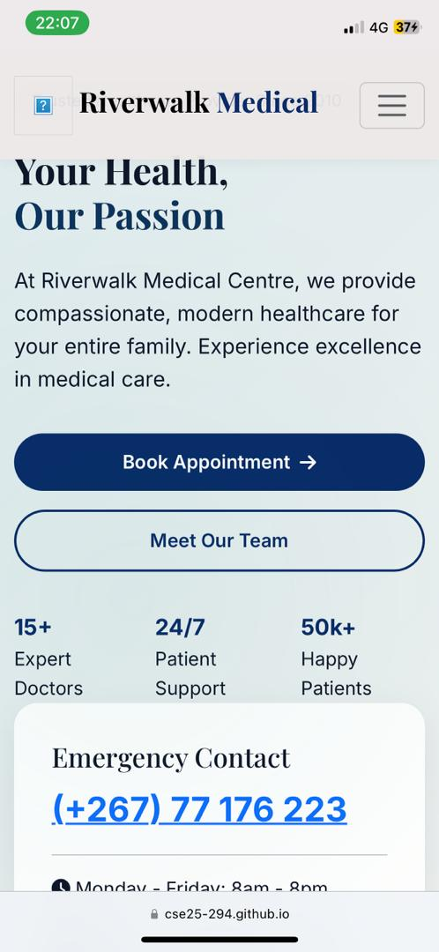
Microsoft screenshot
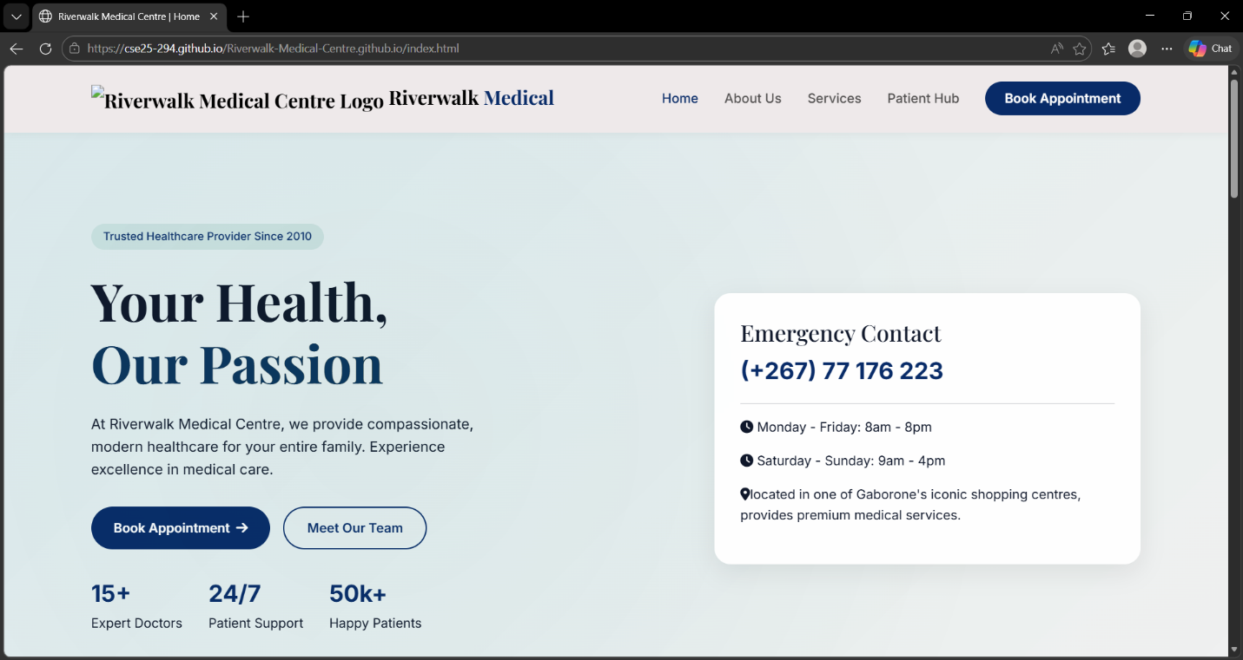
Chrome screenshot
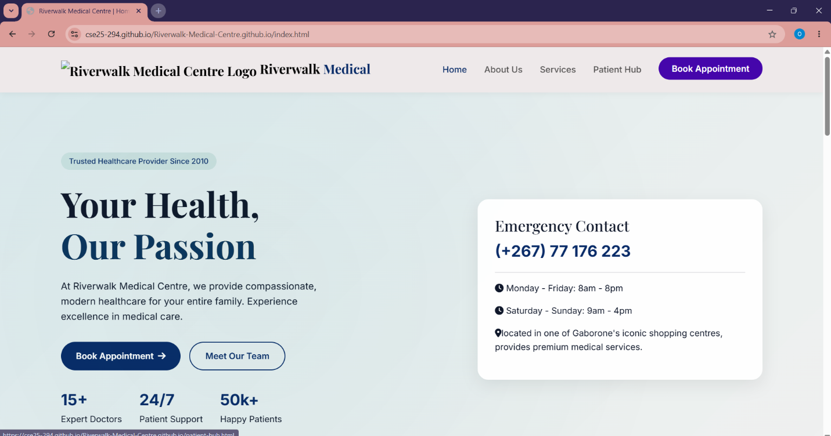

Firefox screenshot
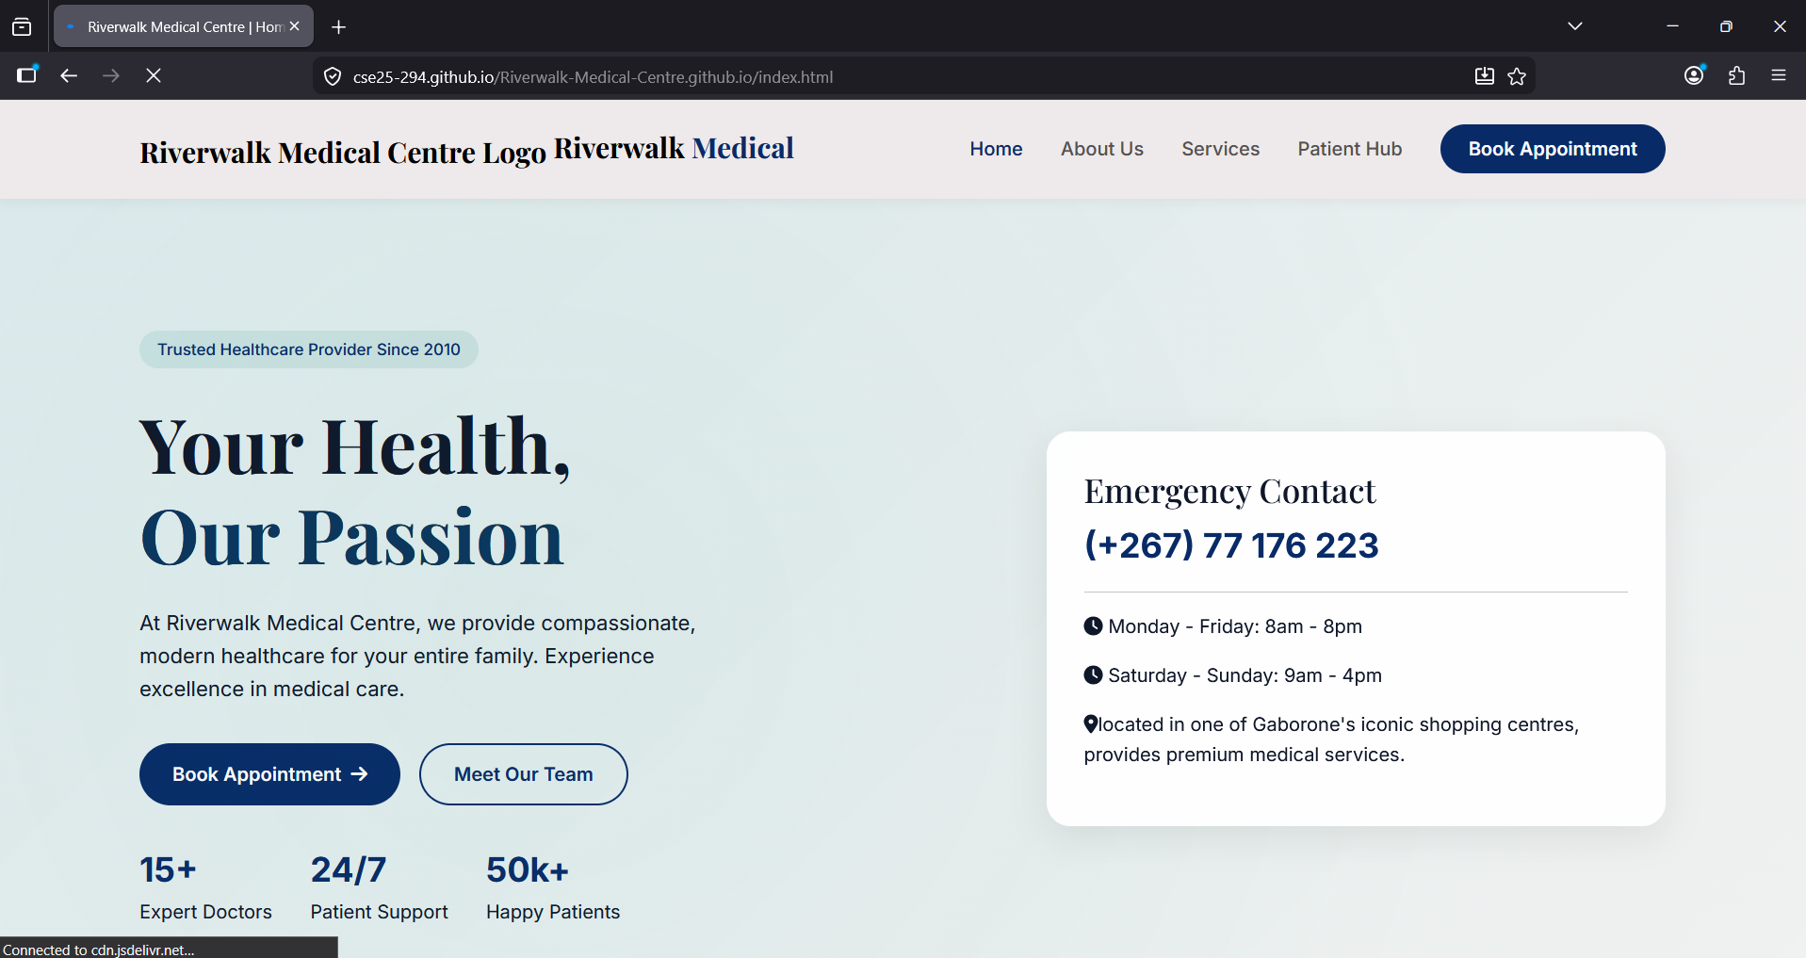

5.3 HTML & CSS Validation
- All pages validated using the W3C Markup Validation Service --- no critical errors found
- style.css validated with W3C CSS Validator --- passes with no errors
- Semantic HTML5 elements used throughout: <nav>, <section>, <footer>, <form>

6. Publishing & Promotion
6.1 GitHub Repository Setup
The website is version-controlled using Git and hosted publicly via GitHub Pages. The repository was created and named using the student's SCIS number as required by the assignment brief.

6.2 Git Commands Used
The following sequence of Git commands was used during the development and deployment process:
bash
git init # Initialize a new local repository
git add . # Stage all project files
git commit -m "Initial website commit: Riverwalk Medical Centre"
git remote add origin https://github.com/[username]/[SCIS-number].git
git push -u origin main # Push to remote repository
GitHub Pages enabled via Settings > Pages > Source: main branch / root --- Publishes the site live.
6.3 Live Website URL
GitHub Repository | cse25-294/Riverwalk-Medical-Centre.github.io
Live Website URL | Riverwalk Medical Centre | Home

7. Future Developments & Recommendations
While the current version of the Riverwalk Medical Centre website meets the assignment requirements and provides a strong foundation, several enhancements could significantly improve its functionality, usability, and business value in the future:
7.1 Back-End Integration
- Connect the Patient Registration form, Test Results Request, and Prescription Refill forms to a real database (e.g., MySQL or MongoDB) via a server-side language such as Node.js or PHP, enabling actual data persistence.
- Implement user authentication to allow registered patients to log in and view their appointment history, test results, and prescription records securely.
7.2 Online Booking System
- Fully integrate the HotDoc booking API rather than relying on a JavaScript alert placeholder, enabling real-time appointment scheduling within the website itself.
7.3 Accessibility Improvements
- Add ARIA labels, keyboard navigation support, and high-contrast mode to comply with WCAG 2.1 AA accessibility standards, ensuring the website is usable by patients with visual or motor impairments.
7.4 Performance Optimisation
- Implement image lazy loading and convert all images to WebP format to reduce page load times on mobile connections.
- Add a service worker for offline support and faster repeat-visit performance (Progressive Web App features).
7.5 Content Management
- Integrate a lightweight CMS (e.g., WordPress or Contentful) so non-technical clinic staff can update the health blog, doctor profiles, and opening hours without coding knowledge.
- Add multi-language support (English and Setswana) to better serve the full Botswana patient demographic.

